_______________________________________

Appalachian Englishes in the Twenty-First Century
Educational Materials
_______________________________________

Chapter 1

Discussion Questions:
1. What does Hasty mean by saying that terms like dialect and language are “socially rather than linguistically defined”?
2. What are the differences between the definitions of Appalachia: geographically, politically, socially, perceptually, and linguistically?
3. Hasty discusses three major phonological differences distinguishing Northern and Southern Appalachia, /ai/ ungliding, /æ/ breaking, and the low back vowel merger. Have you experienced any of these differences for yourself? Did any of these surprise you? Have you noticed other phonological differences between parts of Appalachia or between Appalachia and other areas of the country?
4. Hasty mentions that West Virginia and Kentucky are “border states” between different regions of the country. Discuss why and how proximity to other geographic and/or linguistic regions would have an impact on language use within these states. Compare and relate this status of being “on the border” with what you learn in Cramer’s Chapter 5.
5. Discuss how and why being from an urban versus a rural area would be important for influencing the language variation in any one person?

Project ideas
1. Let’s take a look at /ai/ ungliding variation. Develop a list of 5 words containing the vowel sound /ai/ before a voiced consonant sound (e.g., b, d, ɡ, v, z, r, l) like pride, bribe, or prize, and develop another list of 5 words containing the vowel sound /ai/ before a voiceless consonant sound (e.g., p, t, k, f, s) like kite, pipe, or price. Add in 10 other words that do not contain an /ai/ vowel, and mix all of these words up in random order. Print out this list of words and ask at least 15 people to pronounce these words. Listen carefully to the /ai/ words, paying attention to whether the /ai/ is pronounced as a diphthong with an upglide or as a monophthong without the upglide. Then, compare the results dividing up the responses by social factors like gender, age, and region.
2. Choose one or more lexical, phonological, and morphosyntactic feature mentioned in this chapter and conduct your own study, asking at least 15 people in your area whether they use these features and whether they hear them being used. Compare the results, dividing up the responses by social factors like gender, age, and region.

The Appalachian Regional Commission’s federal designation of Appalachia:
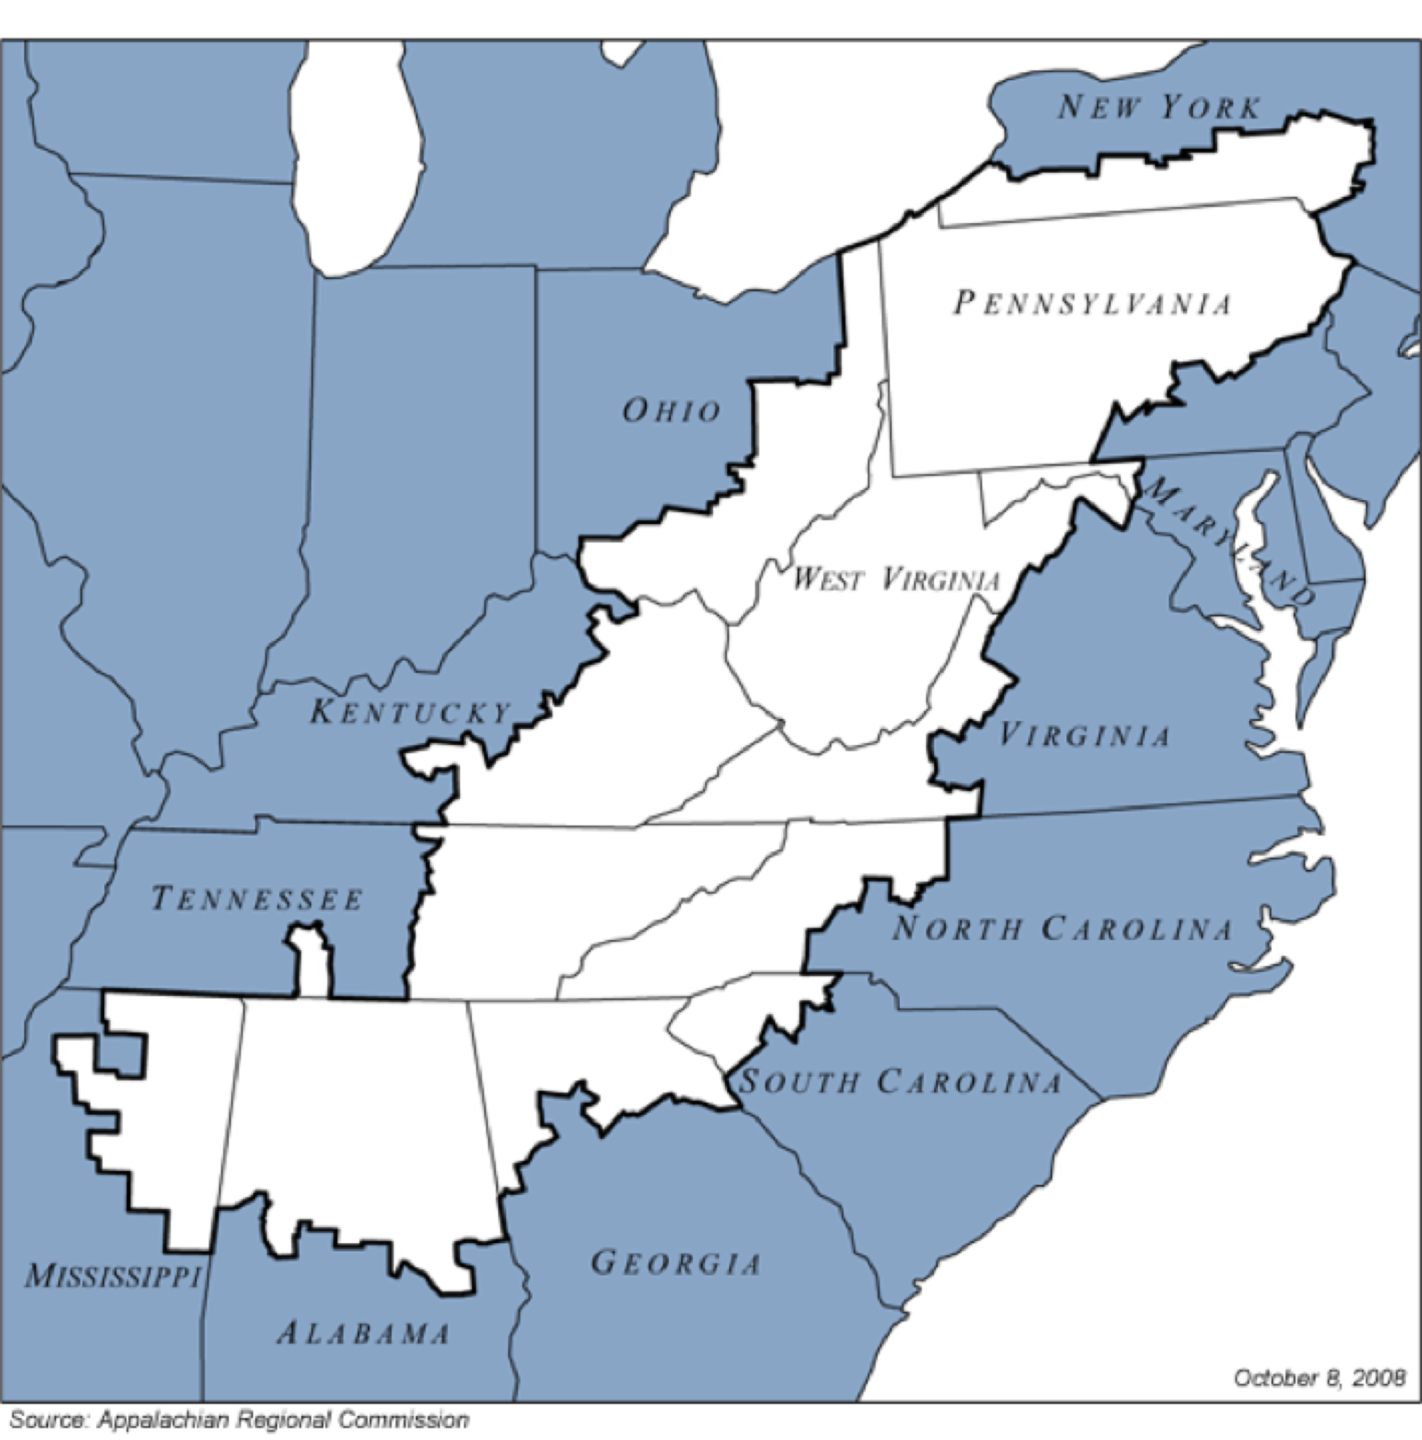

From the Atlas of North American English
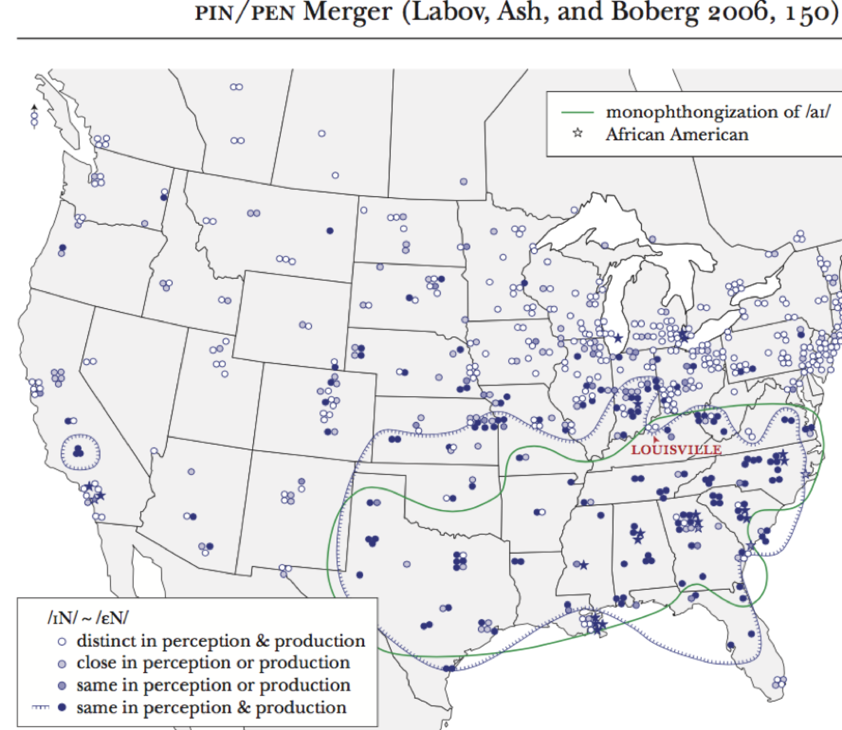

Map of Eastern Dialects from Kurath (1949)
